Jack Berberian

CIS 245

2/26/22

Continue Setup – CentOS Stream 9

Some things to know beforehand:

* By adding -y to a command at the end, you can skip prompts that ask you to confirm whether you’d like to do something like installing a program, removing a program, or upgrading something.
* Sudo is needed for commands that need administrative privileges such as installing a program, and changing system settings to name a few.
* DNF and Yum are two default package managers (software storage places) for Cent OS.

1. How to install Tmux

* Command to enter: **sudo dnf install tmux -y**

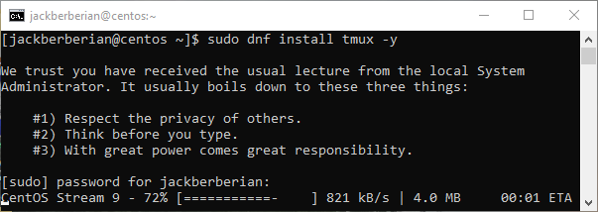

1. How to install emacs

Since emacs isn’t included the with a standard installation of Cent OS, you have to download special packages meant for enterprise users and then install it.

* First command: **sudo dnf install epel-release -y**

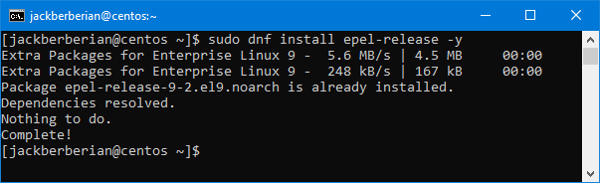

* Second Command: **sudo dnf install emacs -y**

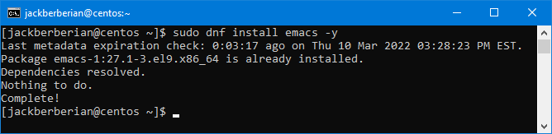

1. How to install Fail2Ban

* Enter: sudo dnf install fail2ban

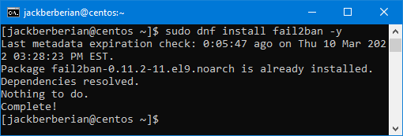

1. How to install cowsay

First enter:

* **Sudo** **wget** [**https://download-ib01.fedoraproject.org/pub/epel/8/Everything/x86_64/Packages/c/cowsay-3.04-16.el8.noarch.rpm**](https://download-ib01.fedoraproject.org/pub/epel/8/Everything/x86_64/Packages/c/cowsay-3.04-16.el8.noarch.rpm)
* Then enter:
* **sudo yum localinstall cowsay-3.04-4.el7.noarch.rpm -y**

What this does is pulls the official package for cowsay from Fedora’s website and then by entering yum localinstall (the filename), it tells the package manager to install the local file from where it’s downloaded in the directory.

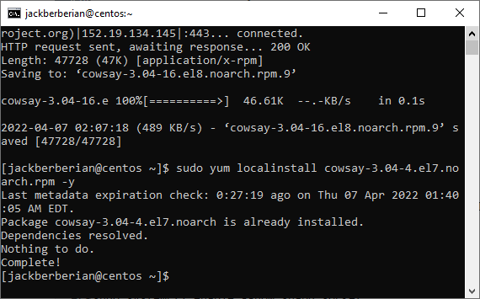

1. How to install lolcat

Here first enter:

1. Sudo yum install snapd
2. sudo systemctl enable --now snapd.socket
3. sudo snap install lolcat

What this does is first install the package manager snapd since lolcat is not available natively, then it’s enabled as a system process and then finally by entering, snap install lolcat, we are able to install lolcat.

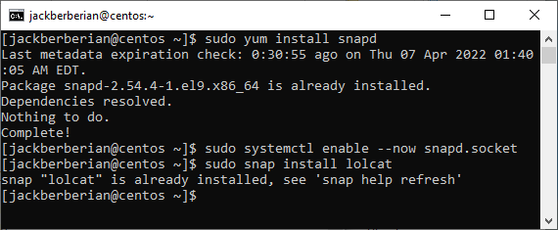

1. How to update VI to vim

Enter:

**Sudo dnf install vim**

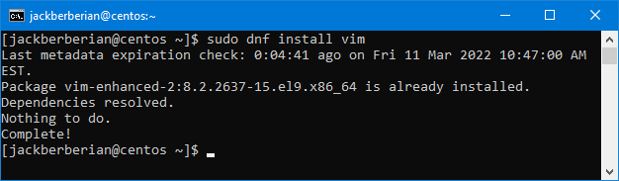

1. How to update your servers if needed

Enter:

1. Sudo dnf update
2. Sudo yum update

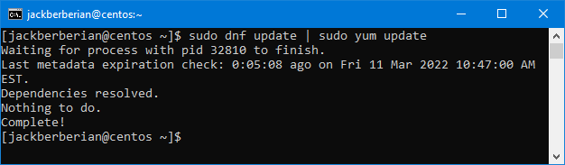

1. Repo List

Enter:

1. Yum repolist
2. Dnf repolist

